1. Enroll for the course LSDOTFRSIXMNTH001

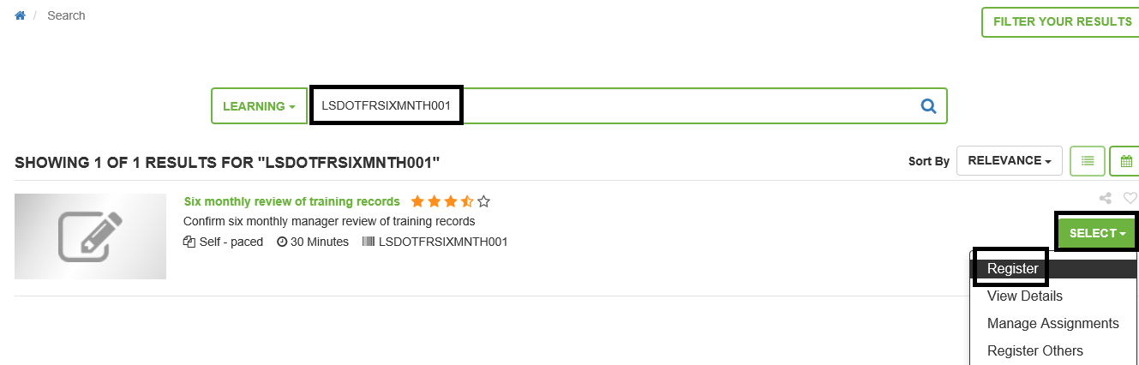

1. Click on Submit to initiate the registration process

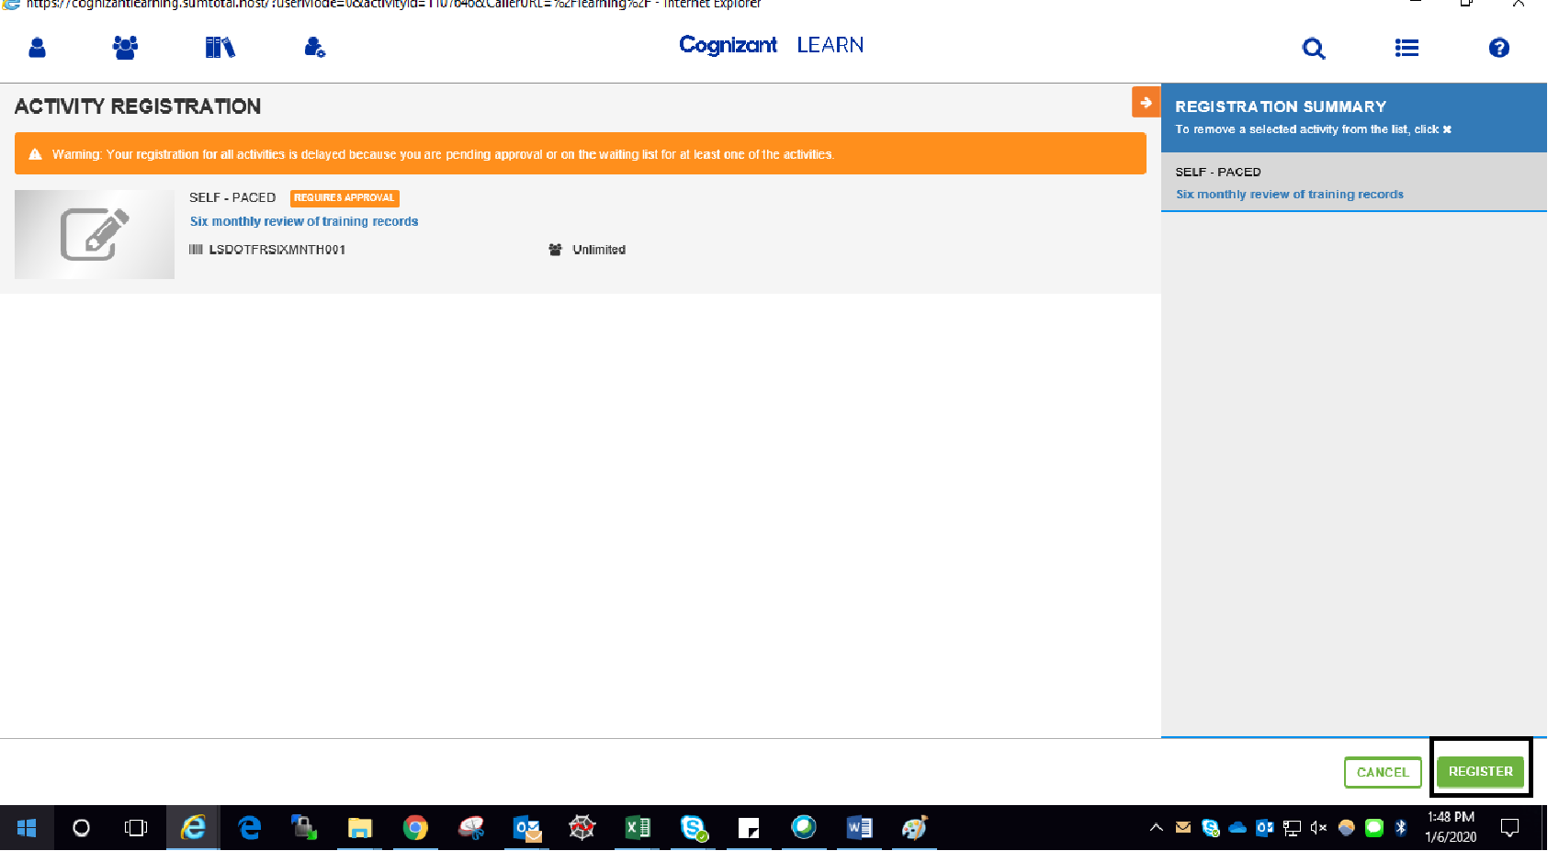

1. Click on Done to complete the registration process

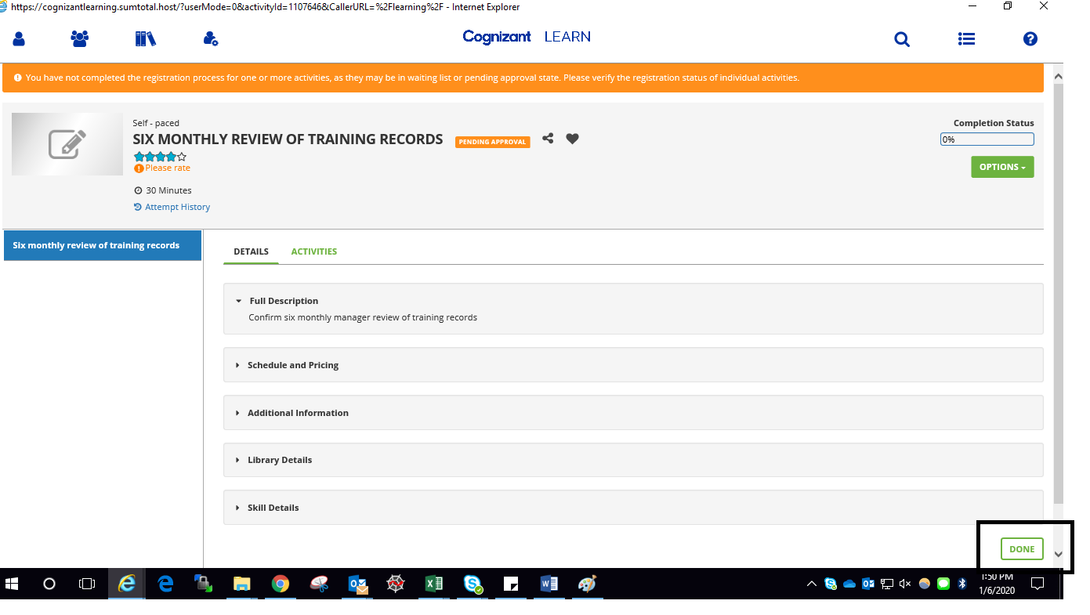

1. Navigate to the Training Schedule page of LEARN. Training should reflect under pending approval list.

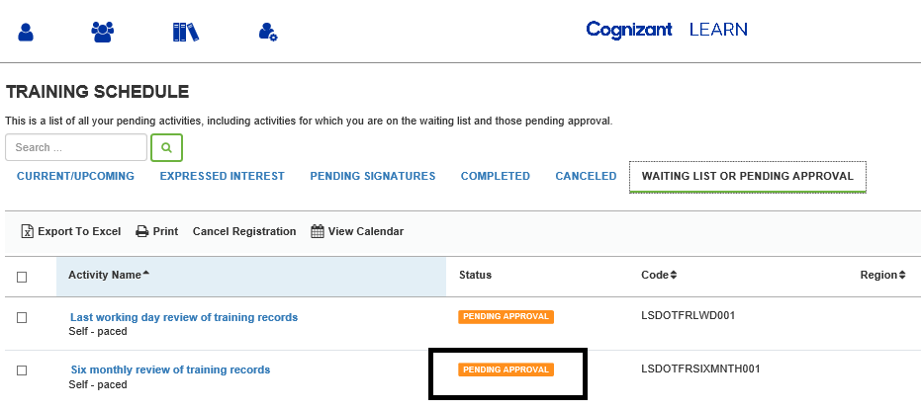

5. GO to learner approvals under Self option

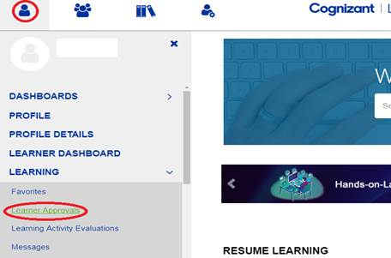

1. Select assigned requests on the learner approvals page, select associate name whose manager review needs to be completed and hit on approve requests.

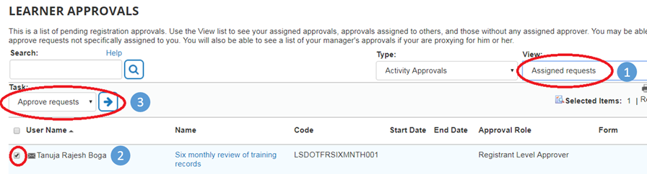

1. Provide approval comments and click on OK to approve the record

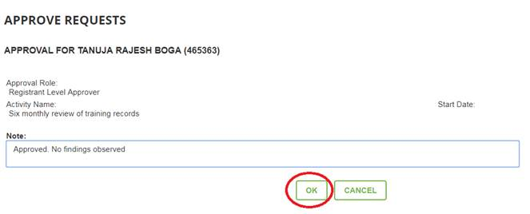

1. After manager’s approval associate to login in LEARN again and navigate to the Training Schedule page of LEARN. Under Current/upcoming activities you will find the course on Immediate supervisor training file review – Q2 2018. Click on the start button to launch the training.

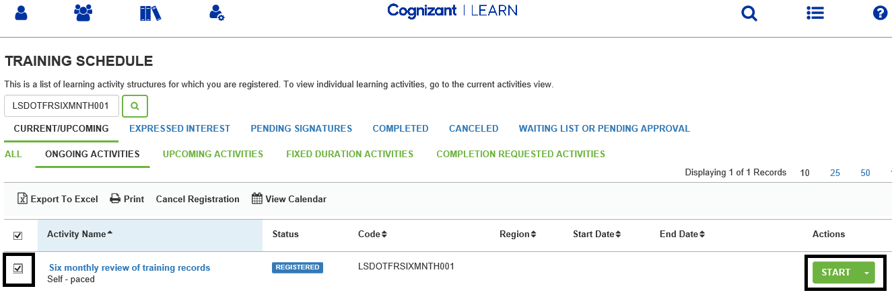

1. Once you click on the start button, an instruction document will open. Please go through the same and then close the document. Below screen will pop up on closing the document. Click on Yes to complete the training.

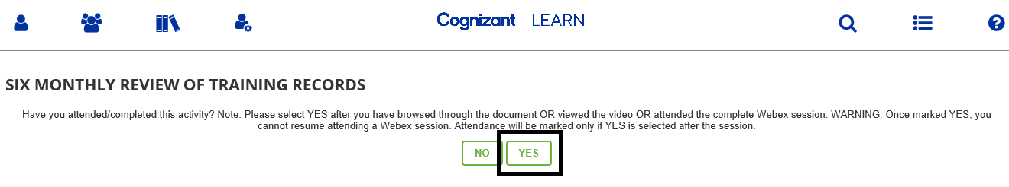

1. Completed training should now reflect under Completed tab of training schedule page as shown below

